H.T No
Regulations:
A19

Sreenidhi Institute of Science and Technology
(An Autonomous Institution)
Code No: 7Z338 Date: 29-Aug-2022 (FN)

MBA II-Year I-Semester External Examination, Aug/Sept-2022 (Supplementary)
QUANTITATIVE APTITUDE AND LOGICAL REASONING

Time: 3 Hours Max.Marks:70

Note: a) No additional answer sheets will be provided.
b) All sub-parts of a question must be answered at one place only, otherwise it will not be valued.
c) Missing data can be assumed suitably.

ANSWER ANY FIVE QUESTIONS. EACH QUESTION CARRIES 14 MARKS.

Bloom's Cognitive Levels of Learning (BCLL)
Remember | L1 | Apply | L3 | Evaluate | L5
Understand | L2 | Analyze | L4 | Create | L6

 |  |  | BCLL | CO(s) | Marks
1. | a) | In certain code 'LOGIC' is written as 'BHFNK'. How is 'CLERK' written in that code? | L2 | CO1 | [7M]
 | b) | When Manoj saw Ashok, he recalled that Ashok was the son of the father of the mother of his daughter. What is Ashok to Manoj? | L1 | CO1 | [7M]
2. | a) | Statements: Some ships are boats. All boats are submarines. Some submarines are yatches.  Conclusion:  i) Some yatches are boats.  ii) Some submarines are boats.  iii) Some submarines are ships.  iv) Some yatches are ships  Which statement/s follow? | L5 | CO2 | [7M]
 | b) | Find the angle between the hands of the clock when the time is 10:30AM. | L4 | CO2 | [7M]
3. | a) | In a certain store, the profit is 320% of the cost. If the cost increases by 25% but the selling price remains constant, approximately what percentage of the selling price is the profit? | L3 | CO3 | [7M]
 | b) | Look at this series: 58, 52, 46, 40, 34, ... . What number should come next? | L2 | CO3 | [7M]
4. | a) | Salaries of Ravi and Sumit are in the ratio 2:3. If the salary of each is increased by Rs. 4000, the new ratio becomes 40:57. What is Sumit's salary? | L4 | CO4 | [7M]
 | b) | i) If class A has 9 boys and 17 girls and class B has 7 boys and 19 girls. Which class has a lesser ratio of boys to girls?  ii) Compare the ratios 5:6 and 7:9 and find which ratio is greater. | L4 | CO4 | [7M]
5. | a) | A bank offers 5% compound interest calculated on a half-yearly basis. A customer deposits Rs. 1600 each on 1st January and 1st July of a year. At the end of the year, What is the amount he would have gained by way of interest? | L3 | CO5 | [7M]
 | b) | A farmer traveled a distance of 61Km in 9hrs. He traveled partly on foot at the rate of 4km/hr and partly on bicycle at the rate of 9km/hr. How much is the distance traveled in km on foot? | L5 | CO5 | [7M]
6. |  | The following pie chart shows the amount of subscriptions generated for India Bonds from different categories of investors.  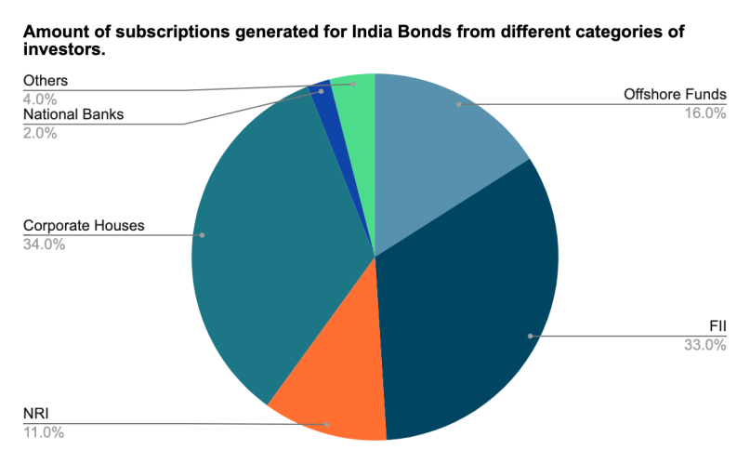  i) In the corporate sector, approximately how many degrees should be there in the central angle ?  ii) If the investment by NRI’s are Rs 4,000 crore, then how much is the investments by corporate houses and FII’s together?  iii) What percentage of the total investment is coming from FII's and NRI's ?  iv) If the total investment other than by FII and corporate houses is Rs 335,000 crore, then how much is the investment by NRI's and Offshore funds (approximately)?  v) If the total investment flows from FII's were to be doubled in the next year and the investment flows from all other sources had remained constant at their existing levels for this year, then what would be the proportion of FII investment in the total investment into India Bonds next year (in US $ millions)? | L5 | CO6 | [14M]
7. | a) | In certain code 'TIGER' is written as 'QDFHS'. How is 'FISH' written in that code? | L2 | CO1 | [5M]
 | b) | What was the day of the week on 17th June, 1998? | L3 | CO2 | [5M]
 | c) | What is the H.C.F. of 9/10,12/25,18/35 and 21/40? | L2 | CO3 | [4M]
8. | a) | Box A has 12 red and 6 blue balls. Box B has 15 red and 9 blue balls. Which box has a greater ratio of red to blue balls? | L4 | CO4 | [5M]
 | b) | The ratio between the speeds of two trains is 7:8. If the second train runs 400 km in 4 hours, then what is the speed of the first train? | L4 | CO5 | [5M]
 | c) | How many tiles, each measuring 2m by 1m, are required to cover a rectangular hall 12m long and 8m broad? Find the cost of tiles at Rs. 25 per tile. | L2 | CO6 | [4M]

-- 00 -- 00 –

